EACH GUEST GETS A PORTION OF EACH DISH
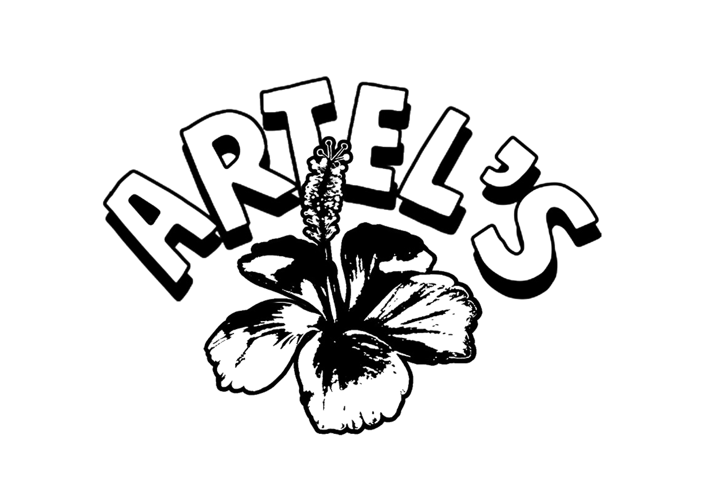

JERK CHICKEN WINGS
24hr Marinated Chicken Wings, finished in BBQ or Hot Sauce

FRIED PLANTAIN VG
Fried and caramelised.

MAC N CHEESE BALLS
Deep fried macaroni and cheese. Served with hot sauce or BBQ.

COLESLAW / CITRUS SLAW
Traditional coleslaw made with white cabbage, carrot, Onions and Mayo or red cabbage, carrot and lime juice.

JERK POTATO BITES VG
Sweet Potato, White Potato & Jerk Spices blended together and coated in Panko breadcrumbs.

SALTFISH FRITTERS
Salted white fish, onions, garlic, deep fried and served as a crispy.

Sauces - Jerk BBQ / Jerk Mayo / Hot Sauce

£20 Per head
No Additional charge

